

**Library Management System**

Author: Mukash uulu Daniiar

December, 2019

**Table of Contents**

1. ACKNOWLEDGEMENT
2. INTRODUCTION
3. EXPLANATIONS
   1. Requirements
   2. Initial Set up
   3. Execution of the program
   4. Login View and Signup view
   5. Admin Views and Users Views
   6. Books view, Add Books, Edit Books, Delete Books
   7. Users view
   8. Profile View

### 1.Acknowledgement:

First of all, I would like to thank my lecturer Mr. Nurlan Shaidulaev for helping me to acquire knowledge of “Java Programming Language”. At the same time, he gave me the opportunity to learn something new related to our module like constructors, methods, arrays, encapsulation etc.

Beside from my lecturer, I like to thank my other classmates for helping to understand the assignment related questions more clearly.

Several terms used inside of project report:

LIS – Library Management System

### 2. Introduction:

This assignment is based on developing a LIS (Library Management System) using Java Programming Language. For that we used GUI (Graphical User Interface) in this development so that it will become more users friendly to interact.

Besides, we also added database to store important data related to our project.

### 4.Explanations:

In this documentation we have given explanations of how to interact successfully with this a LIS. We have explained here step by step so that it will surely help users to become more user friendly with it. Below are our explanations:

#### **Required software:**

Before execute this program, users need to do some works so that it will run properly into their system. First, they need to make sure their system is having “JDK”. If they don’t have it then they can download from this below link:

<https://www.oracle.com/technetwork/java/javase/downloads/jdk8-downloads-2133151.html>

Depending on their system (Windows 64bit/32bit) they need to download and install. Then they need to add the “JAVA” files to their system “PATH” so that the system can run the program from CMD (Command Prompt). The path will show something like this “C:\Program Files (x86)\Java\jre1.8.0_25\bin;”. Now just add the address besides the current path directory and save it.

The other way they can execute this program in to download the IDE (Integrated Development Environment) on their system. They can download ECLIPSE or NETBEANS or IntelliJ depending on the windows (32bit/64bit).

**NETBEANS:**

<https://netbeans.org/downloads/>

**ECLIPSE:**

<http://www.eclipse.org/downloads/>

**INTELLIJ:**

<https://www.jetbrains.com/idea/download/>

We developed this program using “**IntelliJ**”.

Also, we need to install PostgreSQL database which allow us to efficiently store, modify, get, and delete required data for our project. If they don’t have it then they can download from this below link:

<https://www.postgresql.org/download/>

### **4.Project Configuration:**

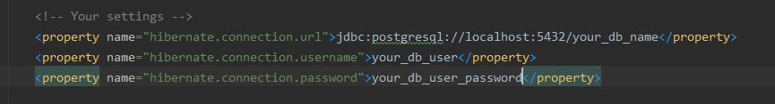After PostgreSQL installation we need to create one database user which will be used as daily database user, also we need to create database to hold our data. After creation of database and user change the values of properties in hibernate.cfg.xml

Figure 1: Configuration file

### **5.Excution Procedure:**

When user executes this program, it will show the startup GUI (Graphical User Interface).

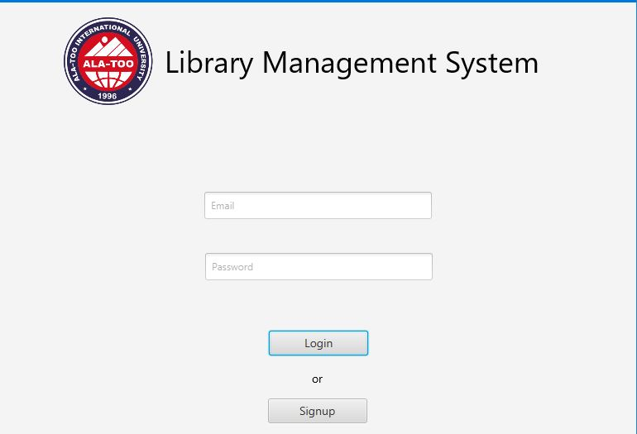Figure 2: Login Screen

Login GUI allows to login with **librarian** and ordinary **user** account.

Now user have to option where to login with his **email** and **password** or user can create new account for himself by making registration to the system. Let’s consider the second option and look at signup process.

## **6.Signup procedure:**

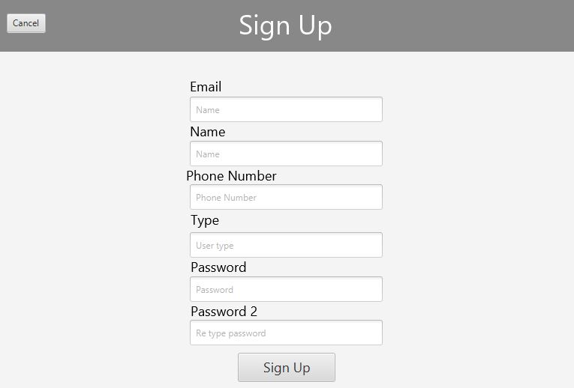Figure 3: Signup Screen

Here user needs to fill all required data about himself like name, email address, phone number, type of user like Student, Staff Member, and etc. Finally, user needs to provide password, both **password and password2 need to be identical**. Also, none of the form fields can be empty or user will see an error telling that some fields are empty. If user made **successful registration** he will be returned to **Login screen**. If user miss clicked the signup button he can be immediately returned to **login screen** by pressing **Cancel** button.

After registration user will be allowed to login to library management system.

## **7.User GUI:**

### **7.1 Books:**

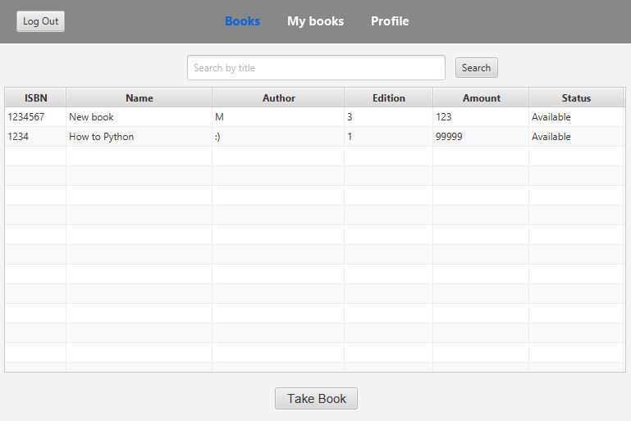After successful authentication user will see Books screen with all books that are currently registered at library management system by librarian.

Figure 4: Books available at LIS

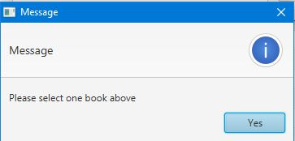Here user can **choose book** and take it by clicking **Take Book** button, if no books is chosen he will see alert ‘**Please select one book above’**

Figure 5: No books selected alert

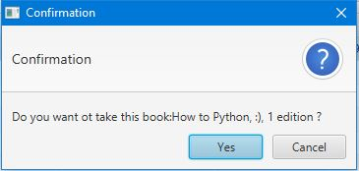If user selected book he will see confirmation box asking whether he wants to add this book to his list.

Taking book will decrease number of available books. If number of specific books reaches zero the book will be unavailable to all users and its status will become **Unavailable**.

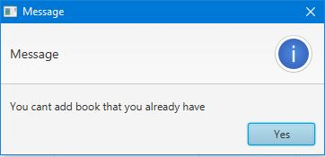If user **already took this book** he will see the alert box telling that user **can’t add this book to his list**.

Figure 7: User already having specific book

All the books that was taken can be seen at **My Books** tab

### **7.2 User Books:**

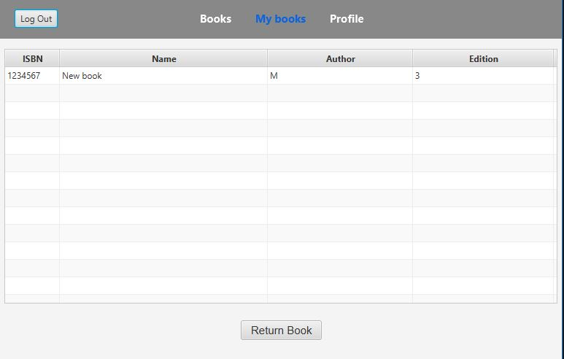Inside of **My Books** tab we can see all the books that was taking by user.

Figure 9: Books that was taken by current user

By clicking **Return Book** user can return book. If no book was chosen user will see alert that no was book was taken, similar to **Books**Screen.

If book was select user will see confirmation box where asking whether he wants to return specific book.

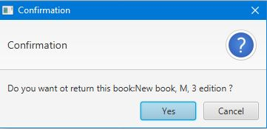**Returning Book** will remove selected book from user’s book list and add to the general book pool and Increase the number of available books.

Figure 8: Return Book confirmation

### **7.3 User Profile:**

Inside of **Profile Tab** we can see all the information about current user and fields that prepopulated with data which is equals to user’s data.

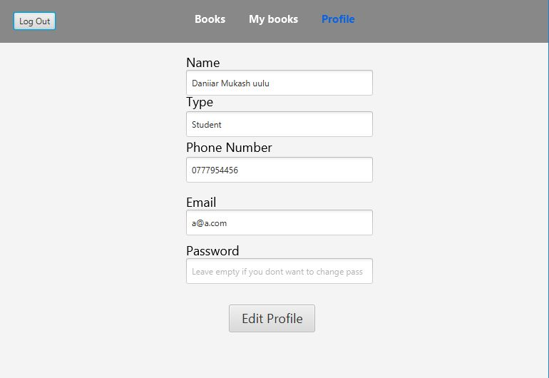

Figure 9: User Profile

Here user can edit data about himself. **None of the fields can be empty except for the password field**, if user is not willing to change his current password he can leave this field empty.

By clicking **Edit Profile** user will update their profile with the data from corresponding fields.

## 8. Librarian GUI

### 8.1 Books:

Now let’s **Login as Librarian**. First thing that librarian sees is the same table with all available books at LIS but with some more control. Librarian can add, delete, and edit books from this **Books** screen.

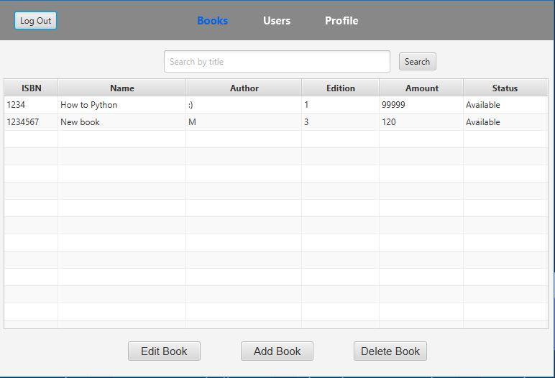

Figure 10: Librarian Books screen

Button Below correspond to actions they describe.

By selecting book and clicking Edit Book librarian will see another screen with book edition form, if no book was selected librarian will see alert box similar to user **Books** screen.

#### 8.1.1 Edit Book:

By Editing special book librarian can increase number of this book, change Name, Author, Edition

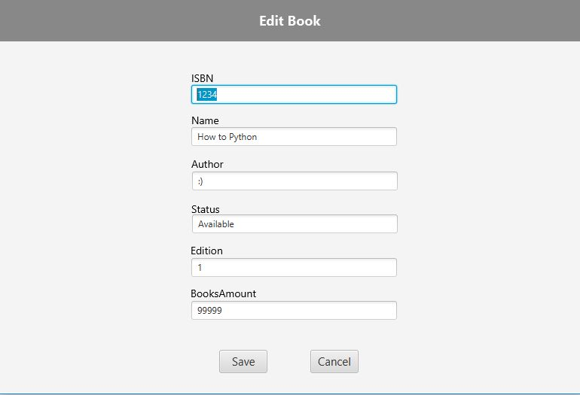

Figure11: Edit Book Screen

By clicking **Save** librarian will save altered data to specific book, after successful editing librarian will return to **Books** Screen, if librarian want to cancel the process it can be done by clicking **Cancel** button.

#### 8.1.2 Add Book:

Adding book have the same screen as Book edit but without prepopulated fields. Here librarian can add new book to LIS, new book will be visible for all users and they will be taking this book.

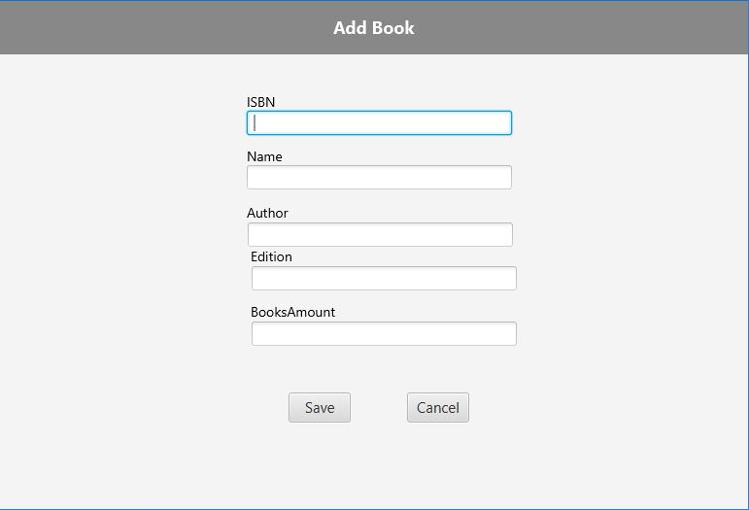

Figure 12: Adding Book to LIS

When adding book none of the fields can be empty or librarian will see error message saying that no fields can be empty. By clicking **Save** librarian will save new book and will return to **Books** screen, but by clicking **Cancel** buttonlibrarian can cancel process of adding.

#### 8.1.3 Delete Book:

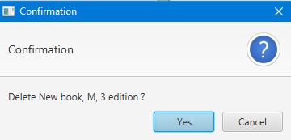Librarian can delete book from LIS by selecting specific book and clicking **Delete Book** button, if no books were selected librarian will see alert box that no book was selected, similar to **Edit Book**. Deleted **book will be removed from all users that took this book**, so be careful with this functionality, but before deleting librarian will see confirmation box. Confirmation box is protection from miss clicking, but it cant guarantee full safety.

Figure 13: Confirmation before Book deletion

### 8.2 Users:

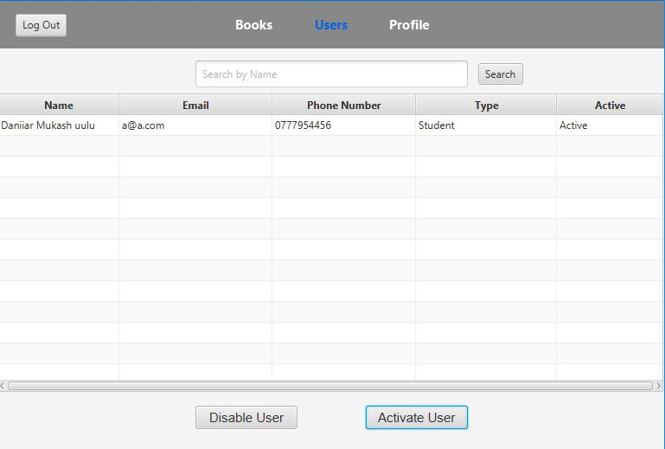Users screen allow to control user’s ability to login by deactivating or activating their accounts

Figure 14: User accounts that registered at LIS

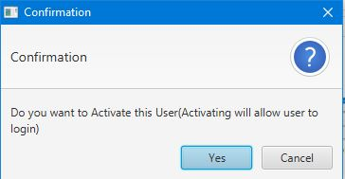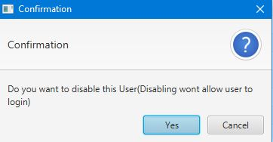By selecting user and clicking Disable User librarian can ban users from LIS, and by Clicking Activate User librarian can grant users ability to login. Before Disabling and Activating users program will show confirmation box to prevent miss clicking. If user is already active or deactivated librarian should see alert box saying that user is already activated or disabled.

Figure 15: Deactivate confirmation Figure 16: Activate confirmation

### 8.3 Profile:

Profile screen the same as ordinary user screen prepopulated with librarian data. Similarly, none of the fields can be empty except for the password. To save changes in librarian profile press Edit Profile button.

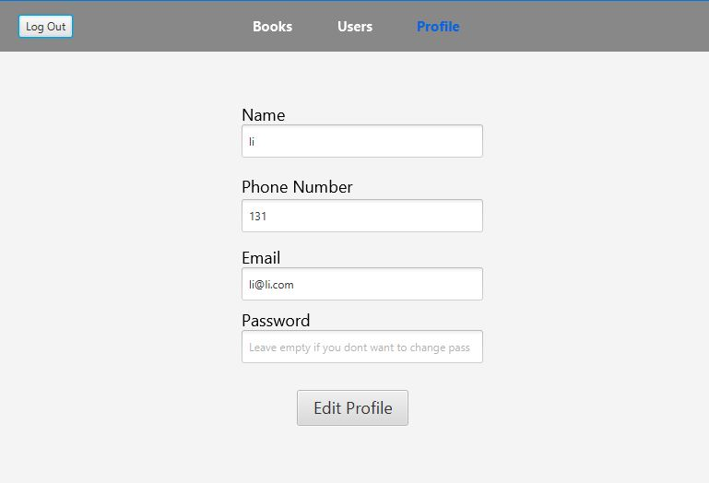

Figure 16: Librarian Profile screen

### 9. Object Oriented Explanation

In object-oriented programming, for example, an object is a self-contained entity that consists of both data and procedures to manipulate the data. In other way, object oriented is the software engineering concept where it is represented using the “OBJECTS”. Below are the objected oriented parts we used in this “Library Management System”:

#### Database connection:

Connection to the database is made with **Hibernate ORM** which allowed to simplify the development process and database design.

#### UML diagram:

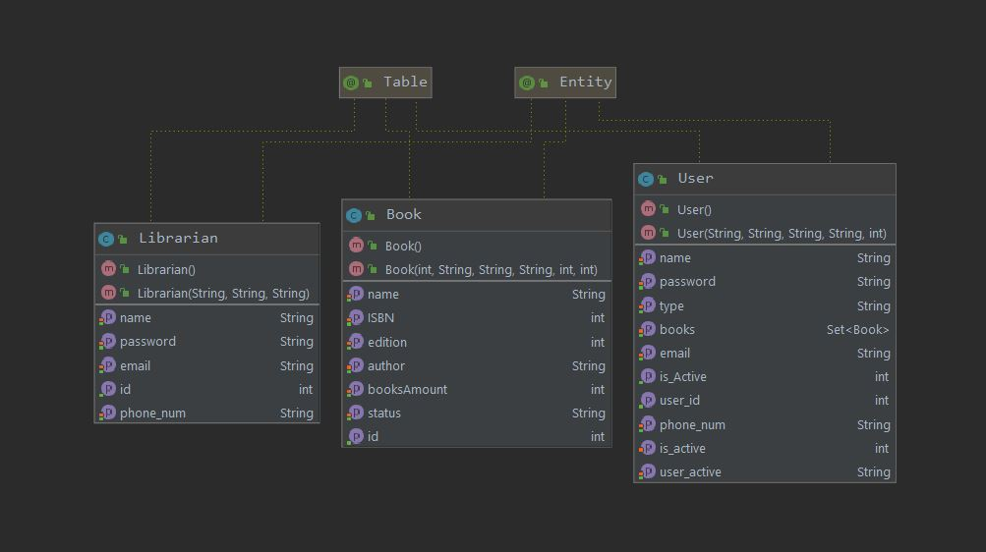

Classes in this diagram represents tables in database, because of ORM every entity of table becomes the instance of that class and its very easy to manage these entities.

#### Main Classes and Methods:

In library management system every functionality is divided into separate reusable code. To give detailed explanation on each function I want to start from the begining of Execution Procedure or Login Screen and give view of the thing that happening under the hood of Library Management System, this way you will get better understanding how specific functions are related and some nuances that need to covered, which will help for the future users or maintainers of this program

##### Login:

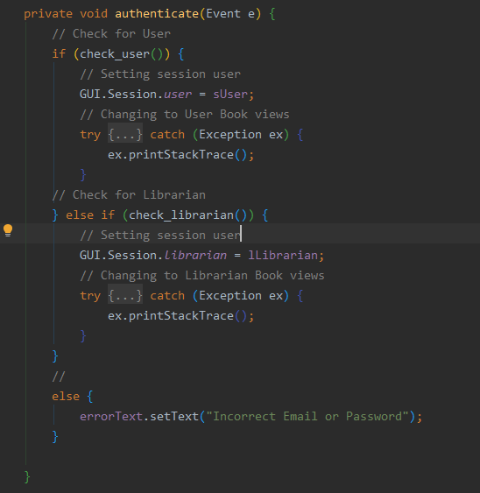When user try to login with his credentials how its determined whether user is a librarian or an ordinary user. **Login process** consist of three main methods **authenticate(), check_librarian(), check_user().**

Authenticate Method

**authenticate()** executes two methods mentioned above if one them return True then users belongs to that category, after it sets User for this session and changes the view to Books view of each user category, if none of them is matching displays an error.

**check_user()** and **check_librarian()** are almost the same function but with difference in table that they make query and that **user can be active or inactive**.

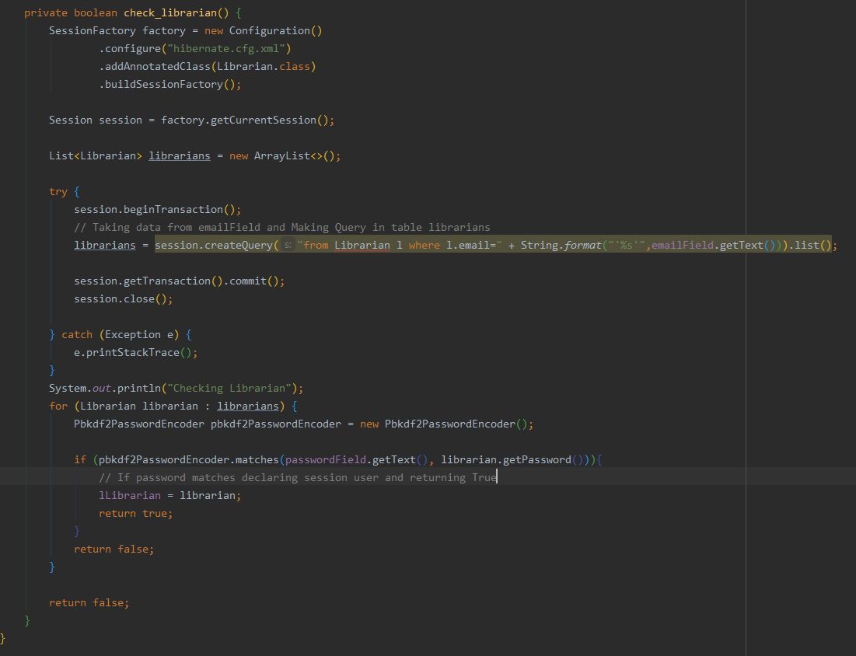Check user



Check librarian

##### Signup:

If user wants to create account in LIS he or she must fill the signup form and submit it. Signup process is bound to **Signup Button.** Every time user clicks it function take data from fields validates it and if every thing is correct saves user to database.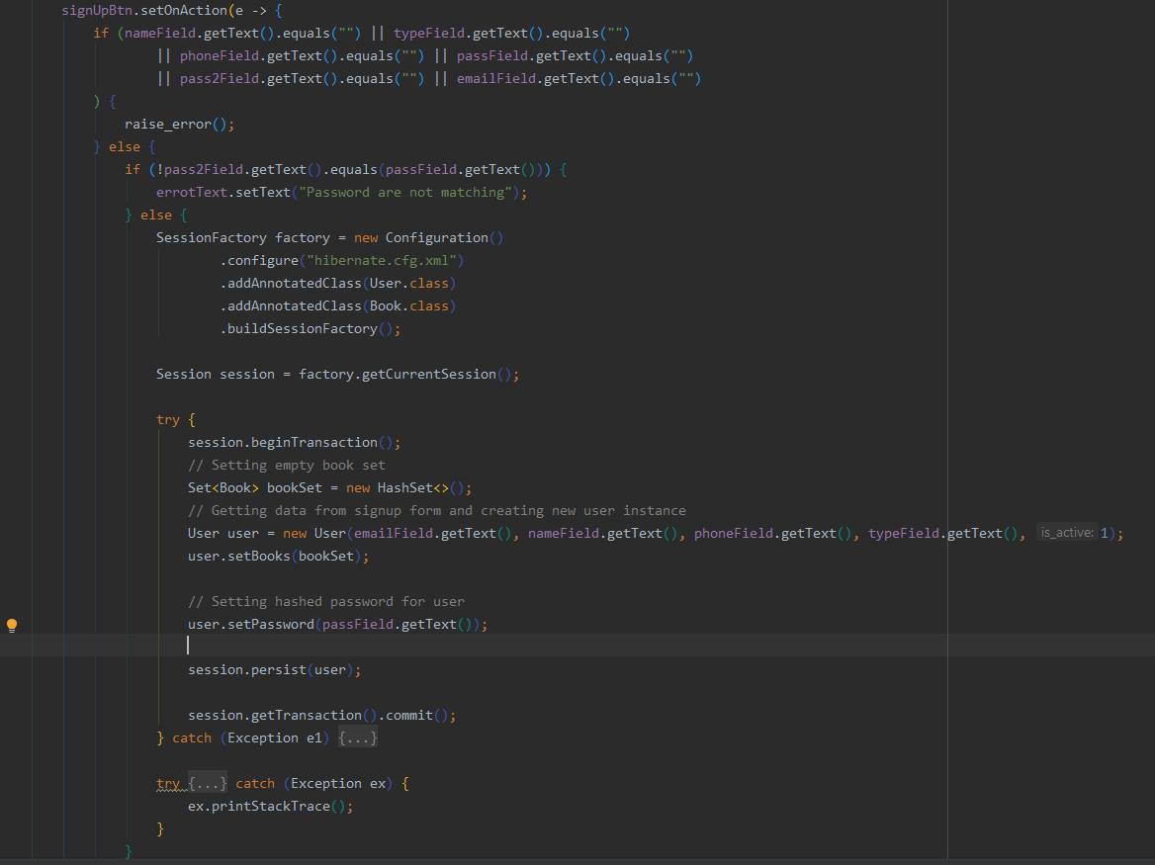

Signup on button click

##### Books:

Books view for both user and librarian are same, there is table view for all available books in LIS and they both can search by their title, but the functionality is different. Let’s first look at **user’s Book View.**

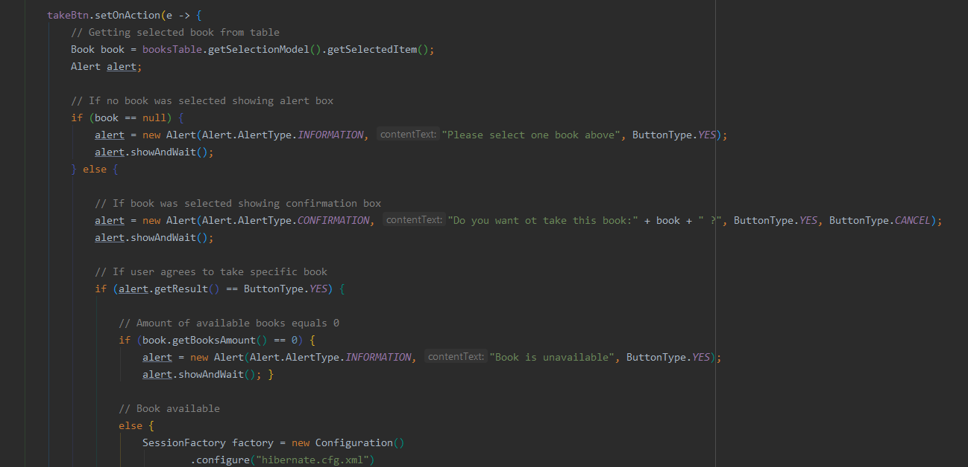

In the picture above described process of taking book first by checking whether the book is available or not.

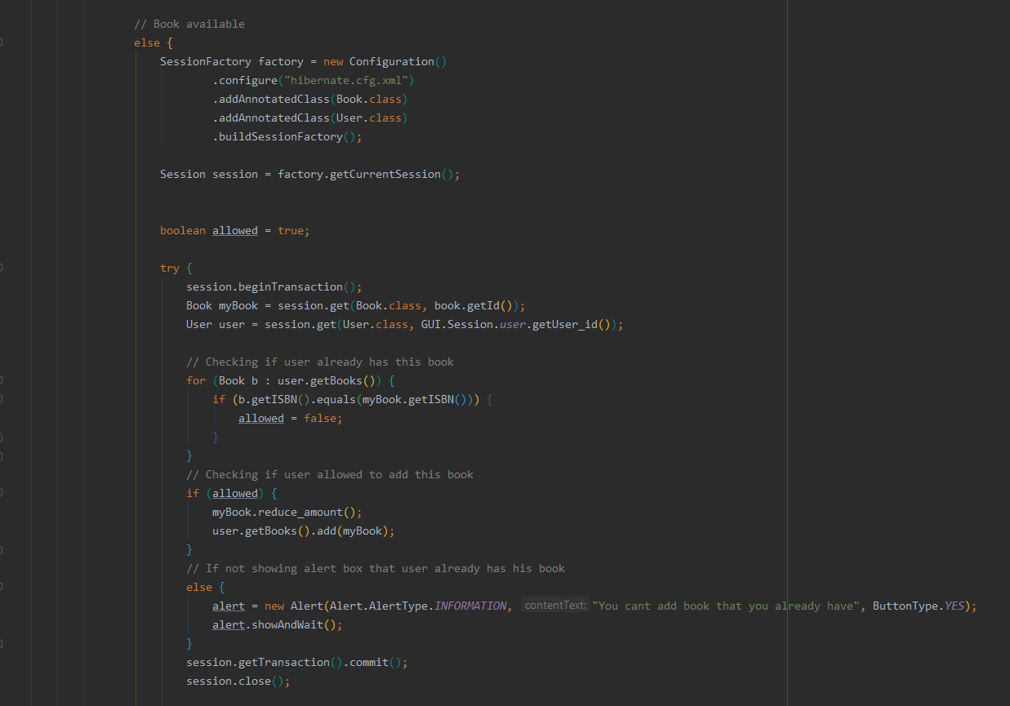

Adding book to users list

After that verifying that user don’t has this book already in his books list.

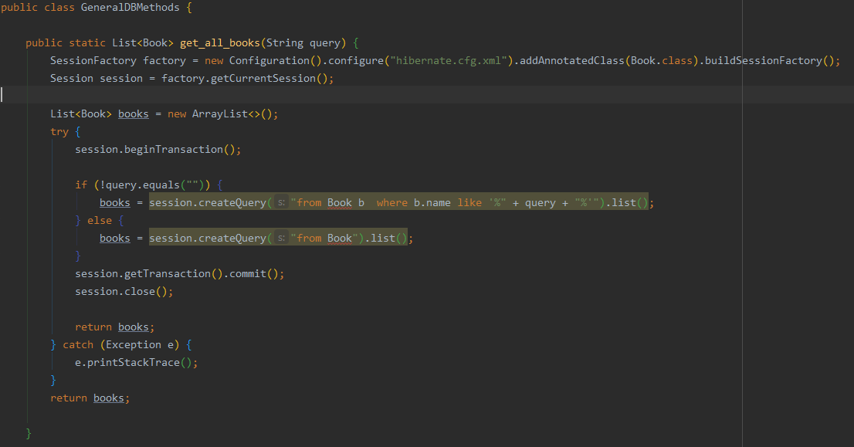**Process of searching** is done by **get_all_books()** static method which returns list of all books if passed arguments is empty string or if other string passed searches for book that contains that string.

Getting books

But Librarian has 3 function available which is **Edit Book**, **Add Book**, **Delete Book**. Under the hood first two method are very similar to what we saw above. First **Edit Book** is similar to **Take Book** from user view but instead of adding book to users Book List and modifying user instance we just update specific Book instance. Second **Add Book** is similar to Signup process, but here instead of user we create book instance.

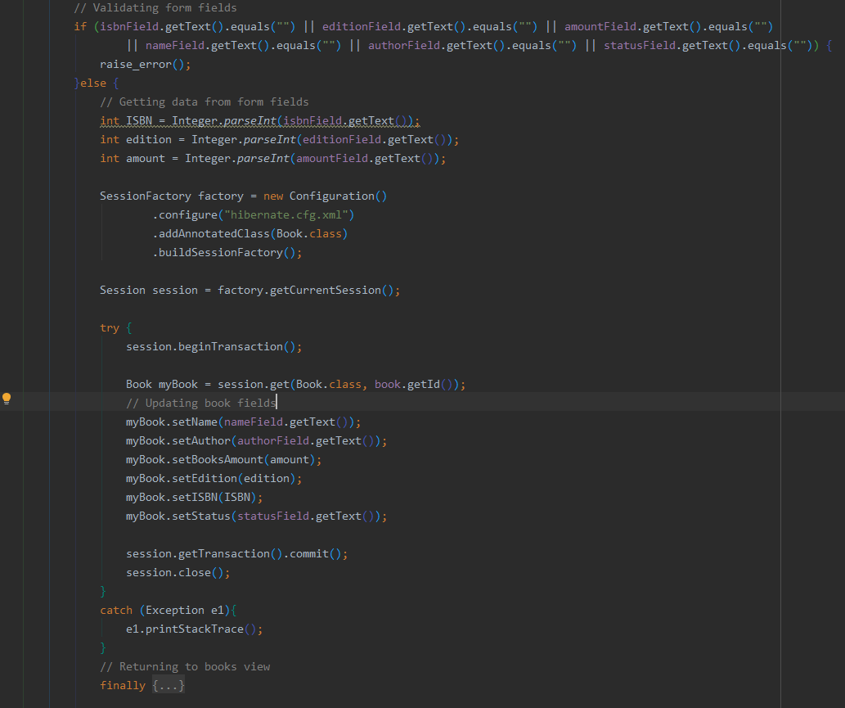

Adding book

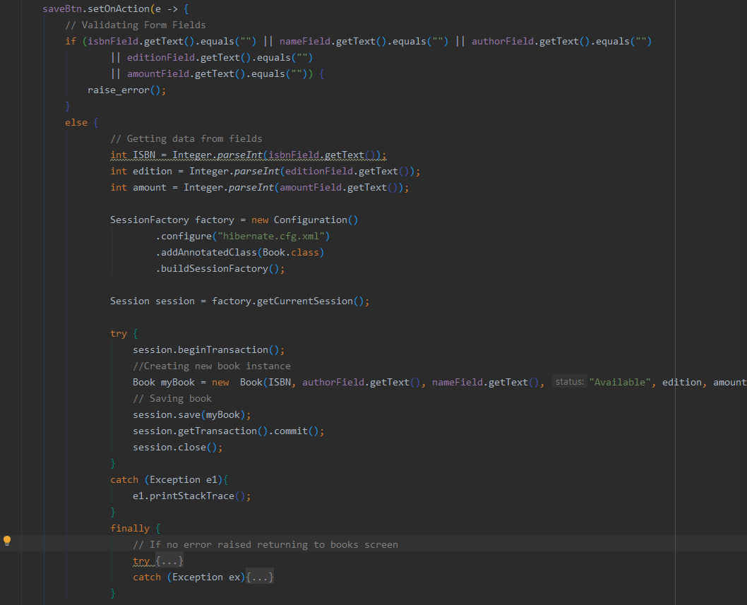

Editing book

But with Delete Book situation is a bit different. When librarian deletes book, it may be linked to users by many to many relations, so database won’t allow to delete until they have relation, also there is no Entity class in my program that will allow to access the database with Hibernate ORM. To overcome this problem program run custom **sql** with **execute_sql** method that deletes relation between users and specific book is it exists.

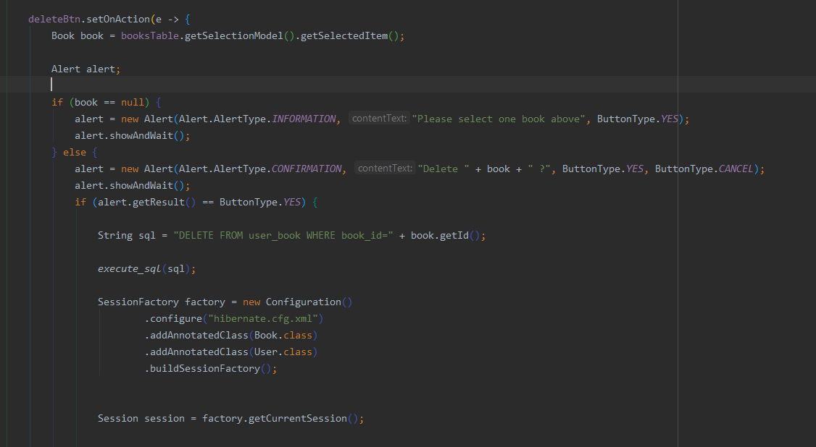

As always showing the confirmation box

After deleting all relations, we can easily delete book from database.

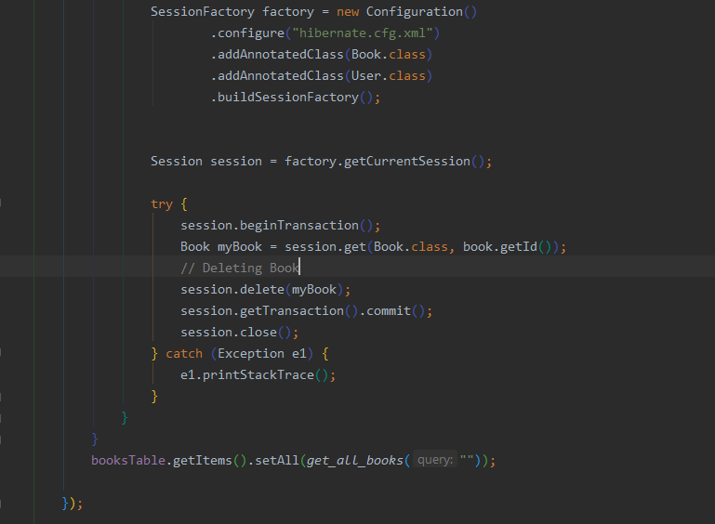

Deleting Book

##### Users Books:

This view allows to user see all the books that they took from library and if they willing to return them back. Process of returning is similar to Adding Book, but now we just remove book from relational table and update user instance.

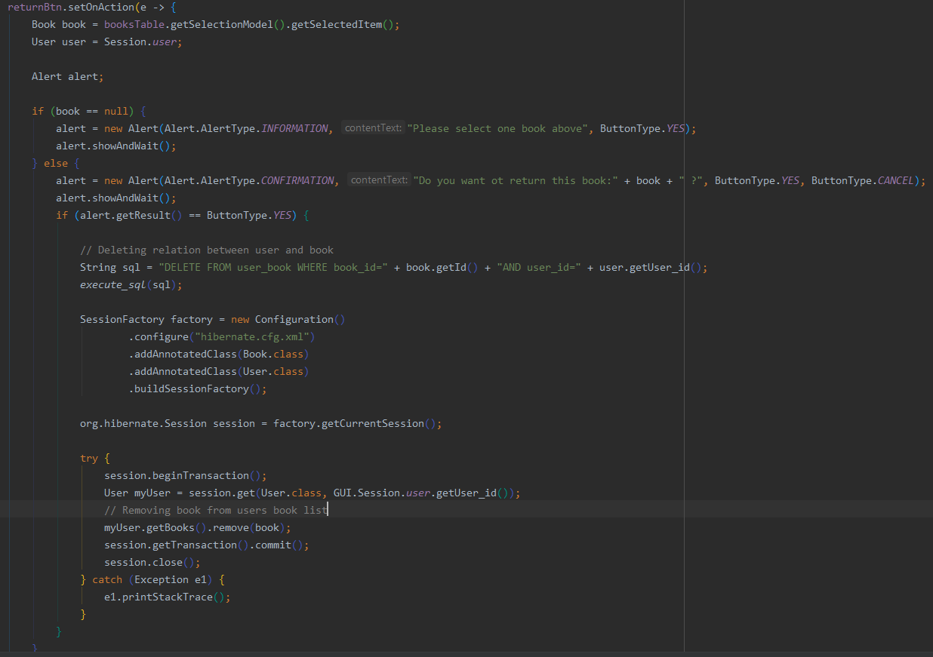

Returning Book back to library

##### Users:

Users view available for librarian gives ability to control whether user can login or not, by updating user_active field in selected user to 0 or 1.